SVM:
• Support Vector Machine
• It does both Classification & Regression.
• Effective for high-dimension spaces.
• It handles both linear and non-linear data.
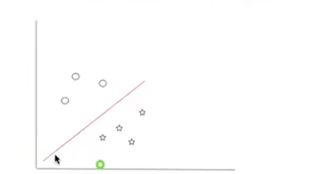

Hyperplane
• 1D / 2D / 3D / n-D -> Hyperplane.
• Decision Boundary
• Margin
• Distance between the sides of hyperplane.
• Objective -> Maximise the margin while reducing the error rate.
• Larger the margin, better the classification.
• Trade off
• Support Vectors:
• data points of both classes lies on the hyperplane.
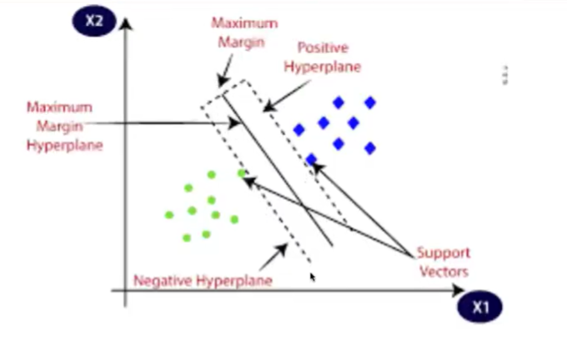
SVM:
• Linear -> Hyperplane.
• Non-Linear -> Not possible to draw a hyperplane on non-linear data.
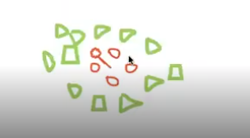
2D to 3D I am trying
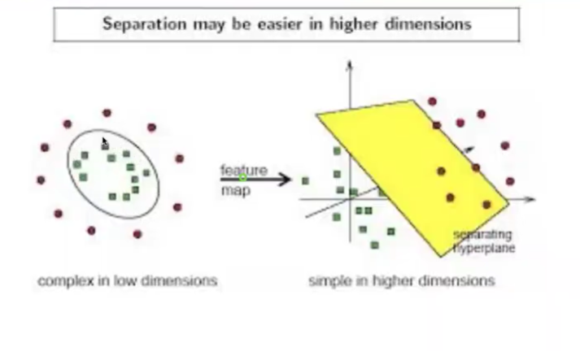
Kernel trick: For non-linear dataset, it transforms the low-dimension to higher dimensional features.
Types of Kernel Tricks:
• Linear Kernel - data is linear separable - No transform
• Polynomial Kernel - Non-linear, transform -> Adds polynomial features.
RBF (Radial basis function) -
• Widely used,
• without prior knowledge of data,
• infinite dimensional spaces.
• measure the similarity among datapoints, then it does the transformation.
Support Vector Regression (SVR):
• Fit a best line like linear regression, try to cover most of the data points which are lying on the line and form a tube that covers the line.
• That tube, is an epsilon. distance between -e and +e is the margin.
• Aim - maximize the margin, reduce the error.
• if the data points are inside the tube, no penalty however there is some errors associated with them.
• if the data points are outside the tube, they should be penalise.
• C - regularization parameters needs to be fine-tuned to find the best line/hyperplane.
• Large of C -> complex model, overfit
• Small of C -> simple model, underfit.
Advantage:
• Linear & non-linear dataset
• High dimensional features.
• Outliers
Disadvantage:
• Computational complex.
• hyperparameter tuning is difficult.
• interpretability. - black box.
• prone to overfitting.

